**Exp:1**

Create a new process by invoking the appropriate system call. Get the process identifier of the currently running process and its respective parent using system calls and display the same using a C program.

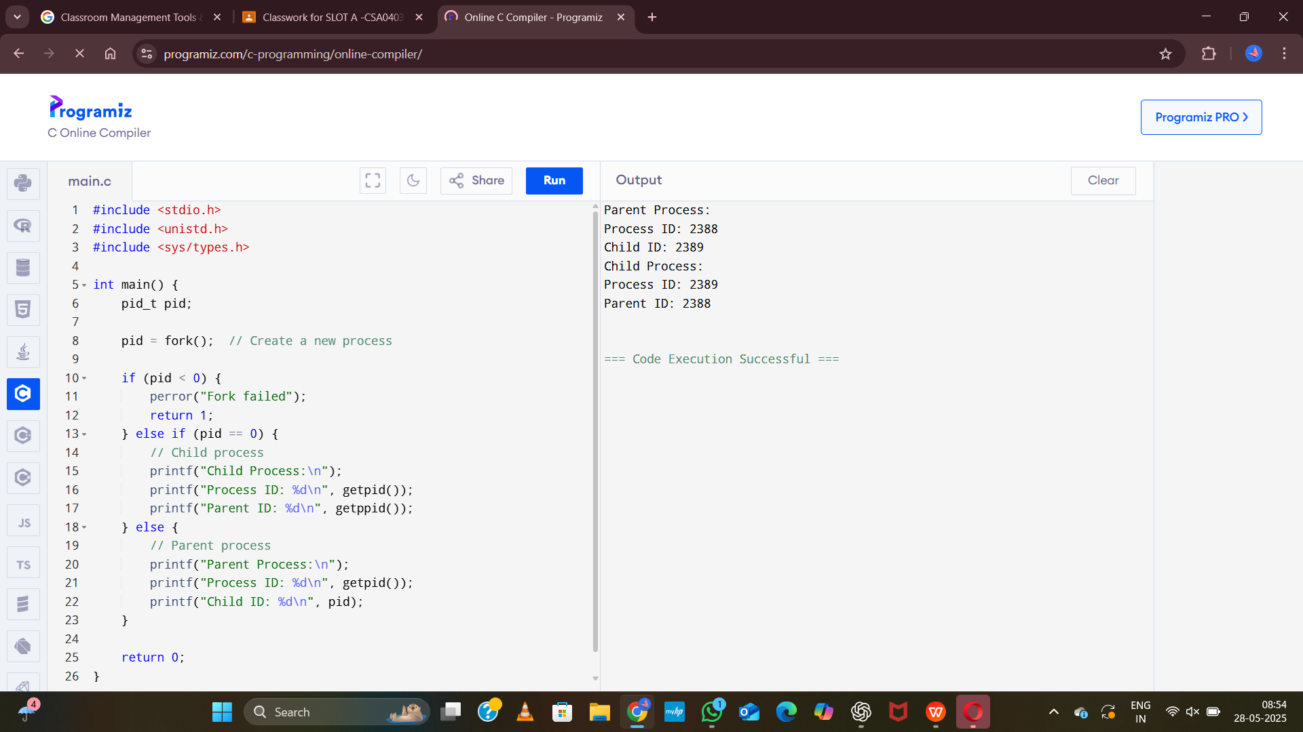

**Exp:2**

Identify the system calls to copy the content of one file to another and illustrate the same using a C program.

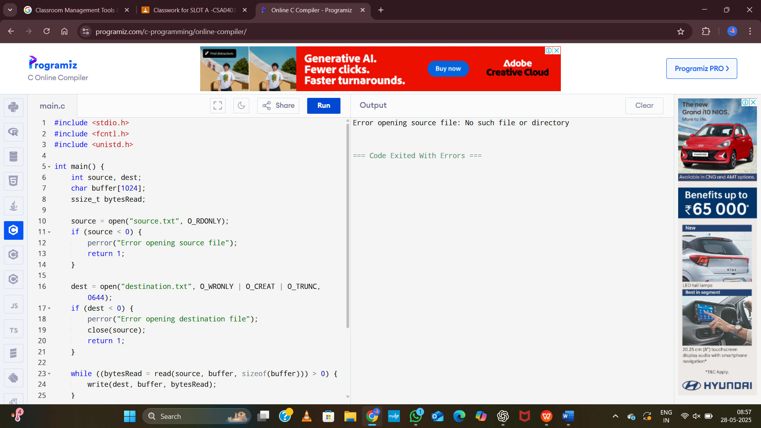

**Exp:3**

Design a CPU scheduling program with C using First Come First Served technique with the

following considerations.

a. All processes are activated at time 0.

b. Assume that no process waits on I/O devices.

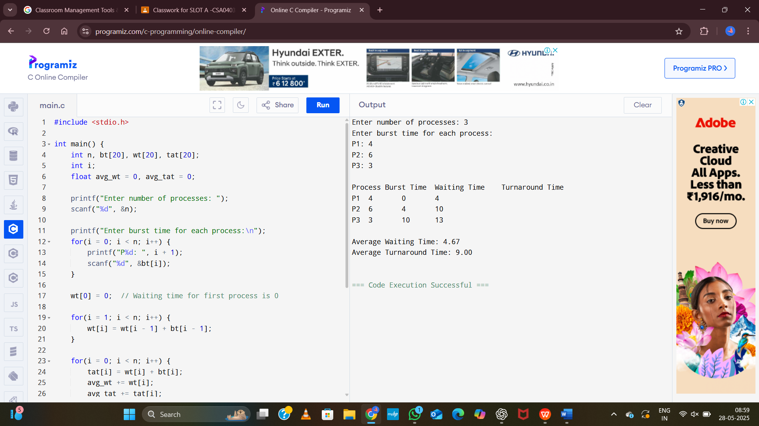

**Exp:4**

Construct a scheduling program with C that selects the waiting process with the smallest

execution time to execute next.

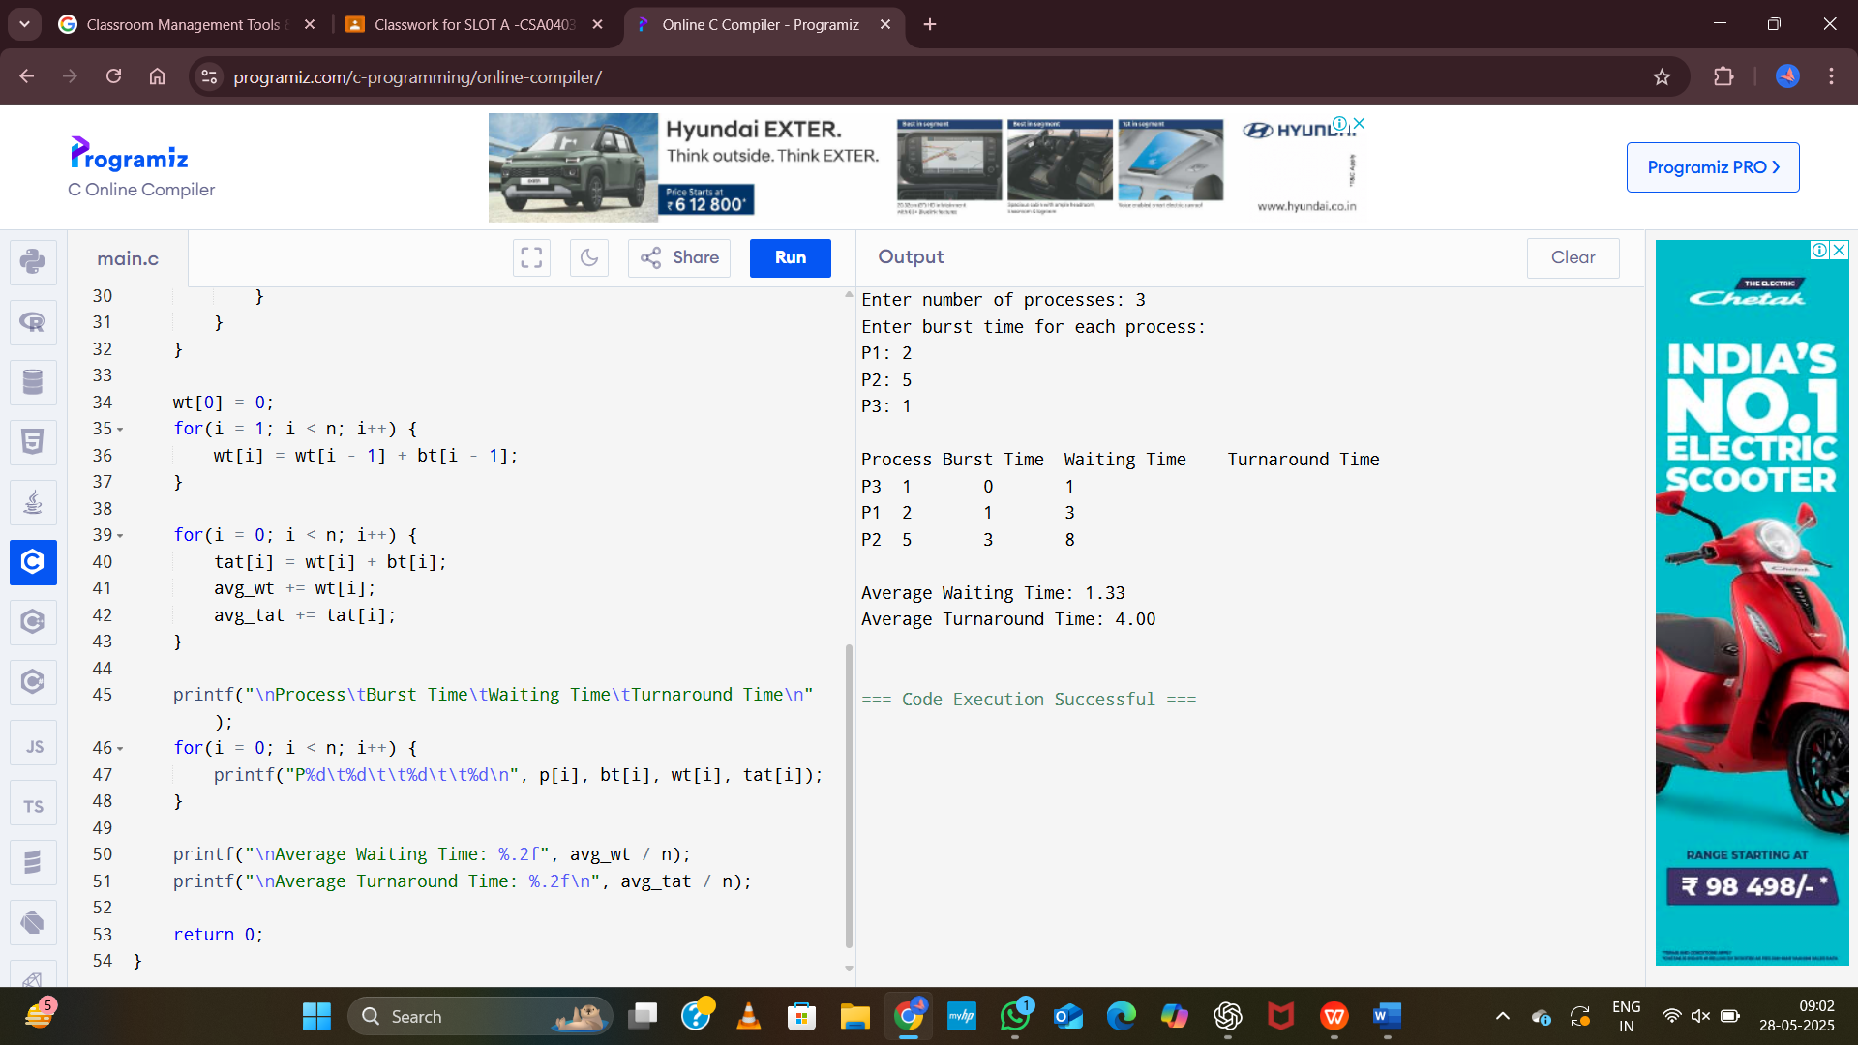

**Exp:5**

Construct a scheduling program with C that selects the waiting process with the highest

priority to execute next.

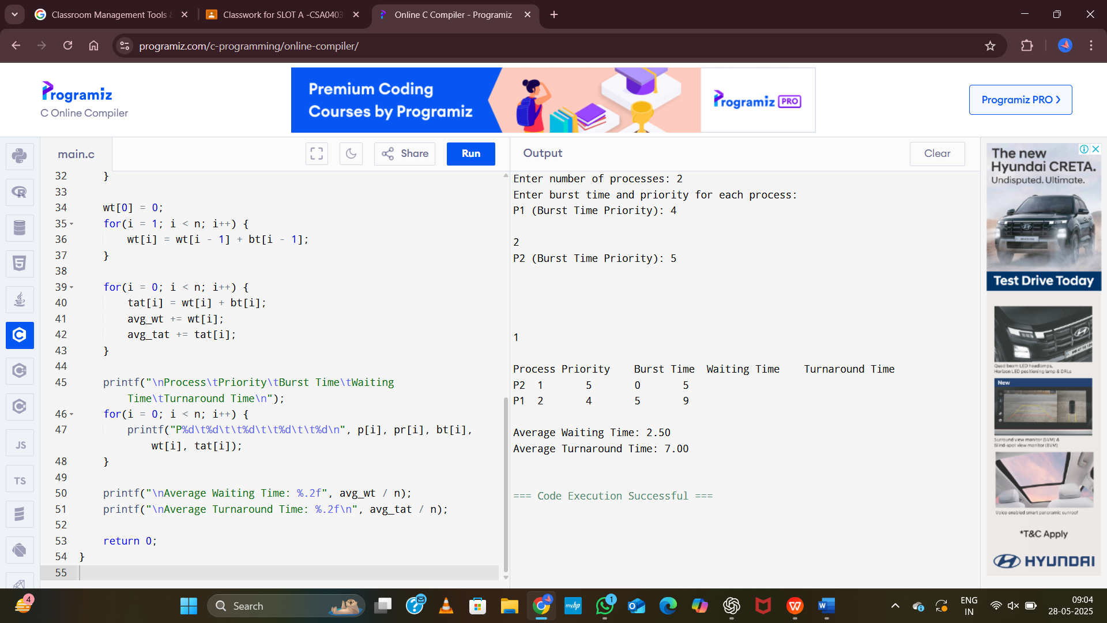

**Exp:6**

Construct a C program to implement pre-emptive priority scheduling algorithm.

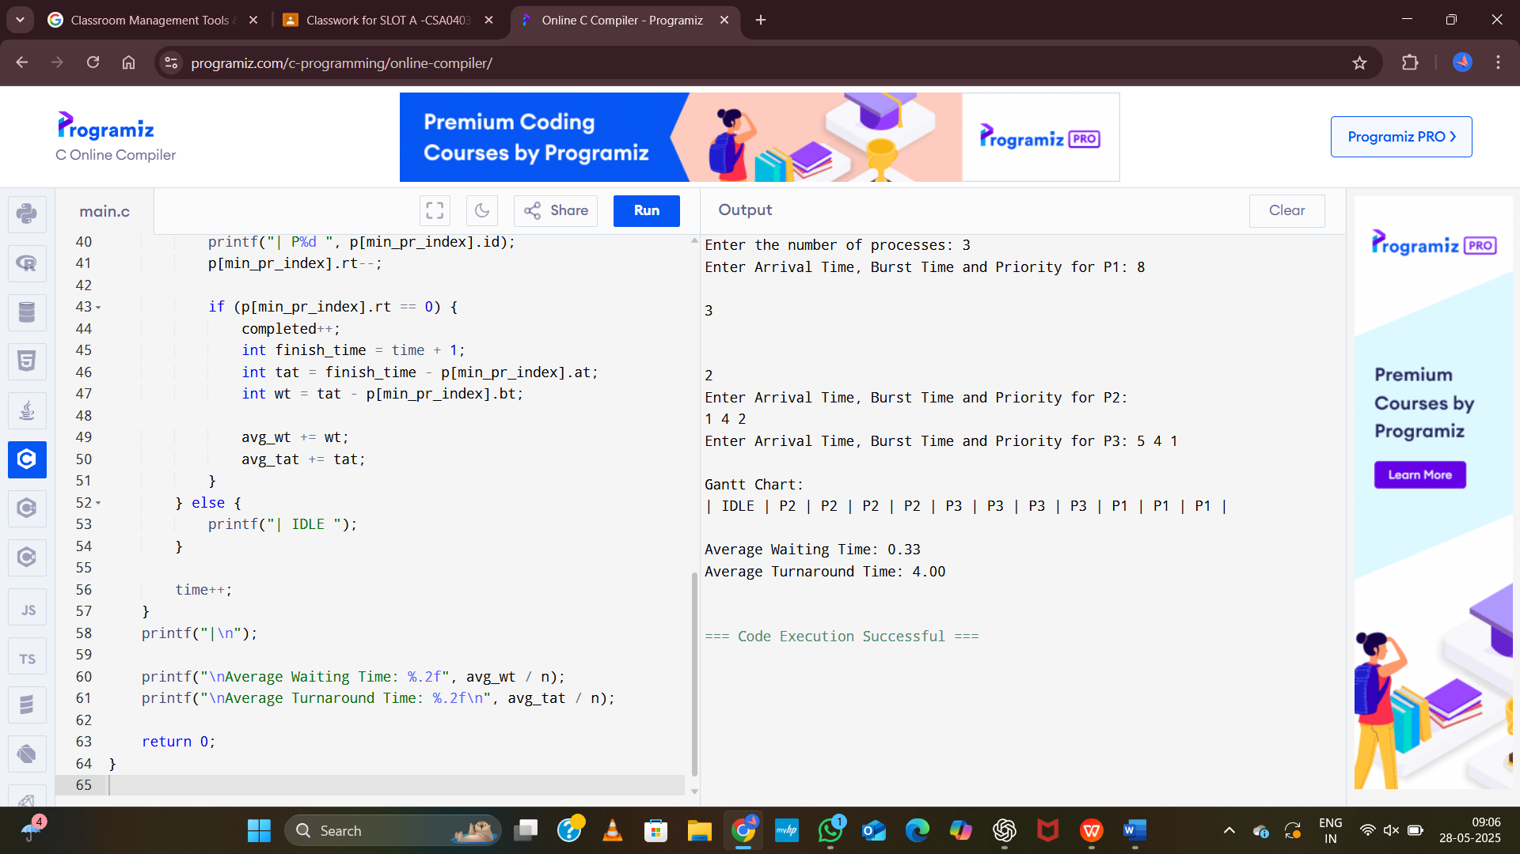

**Exp:7**

Construct a C program to implement non-preemptive SJF algorithm.



**Exp:8**

Construct a C program to simulate Round Robin scheduling algorithm with C.

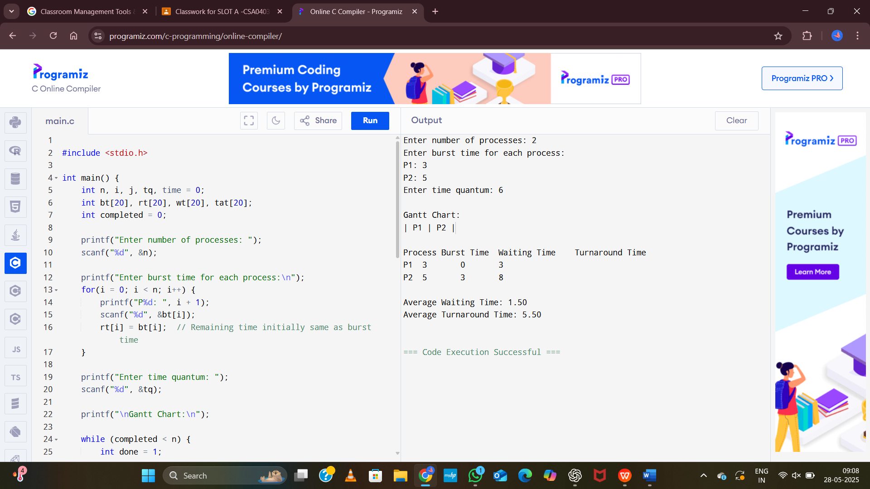

**Exp:9**

Illustrate the concept of inter-process communication using shared memory with a C program.

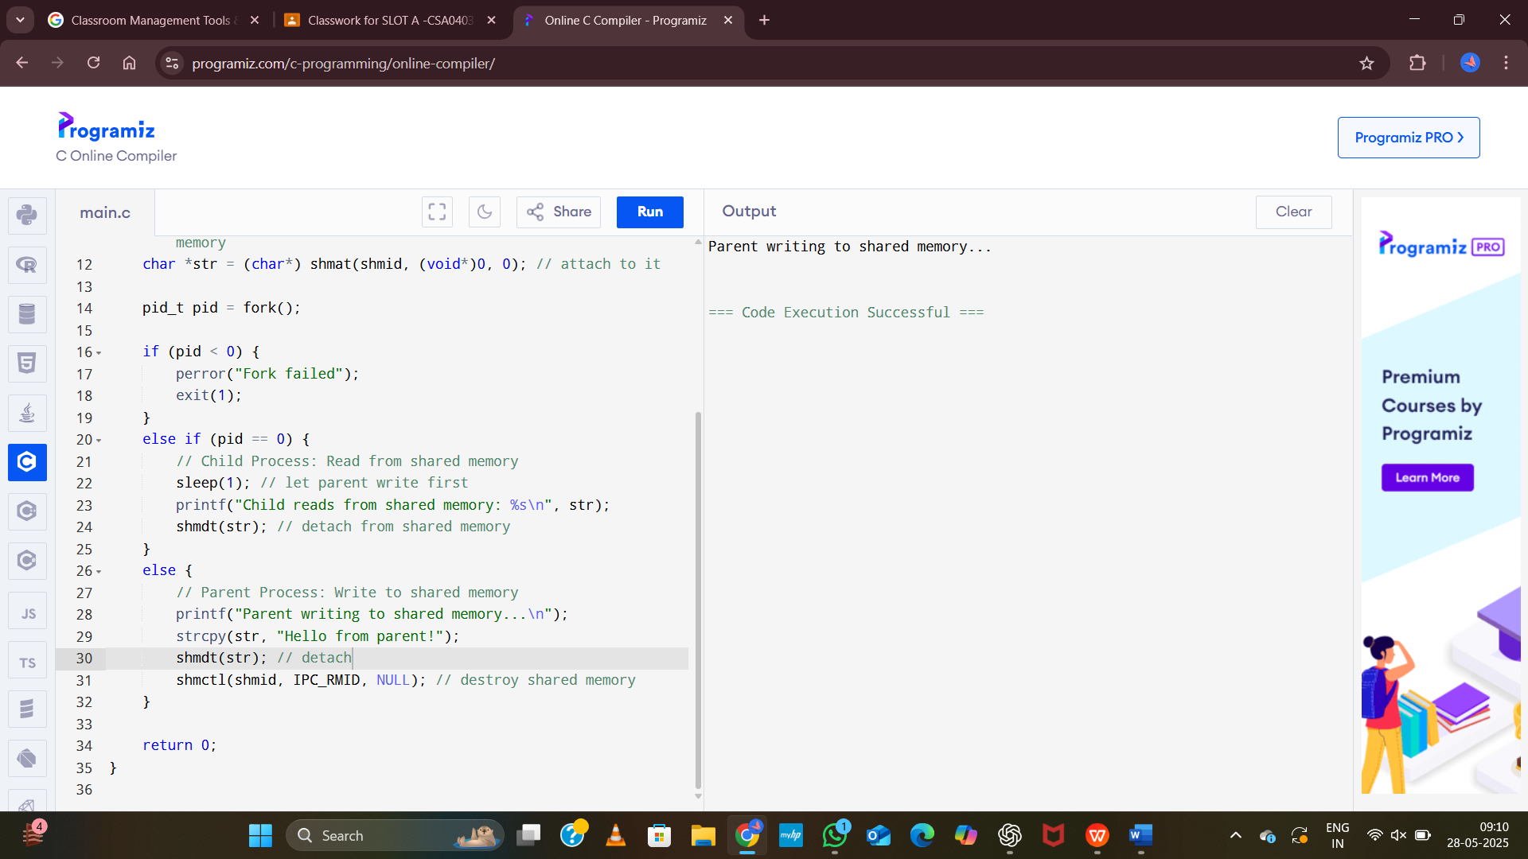

**Exp:10**

Illustrate the concept of inter-process communication using message queue with a C

program.

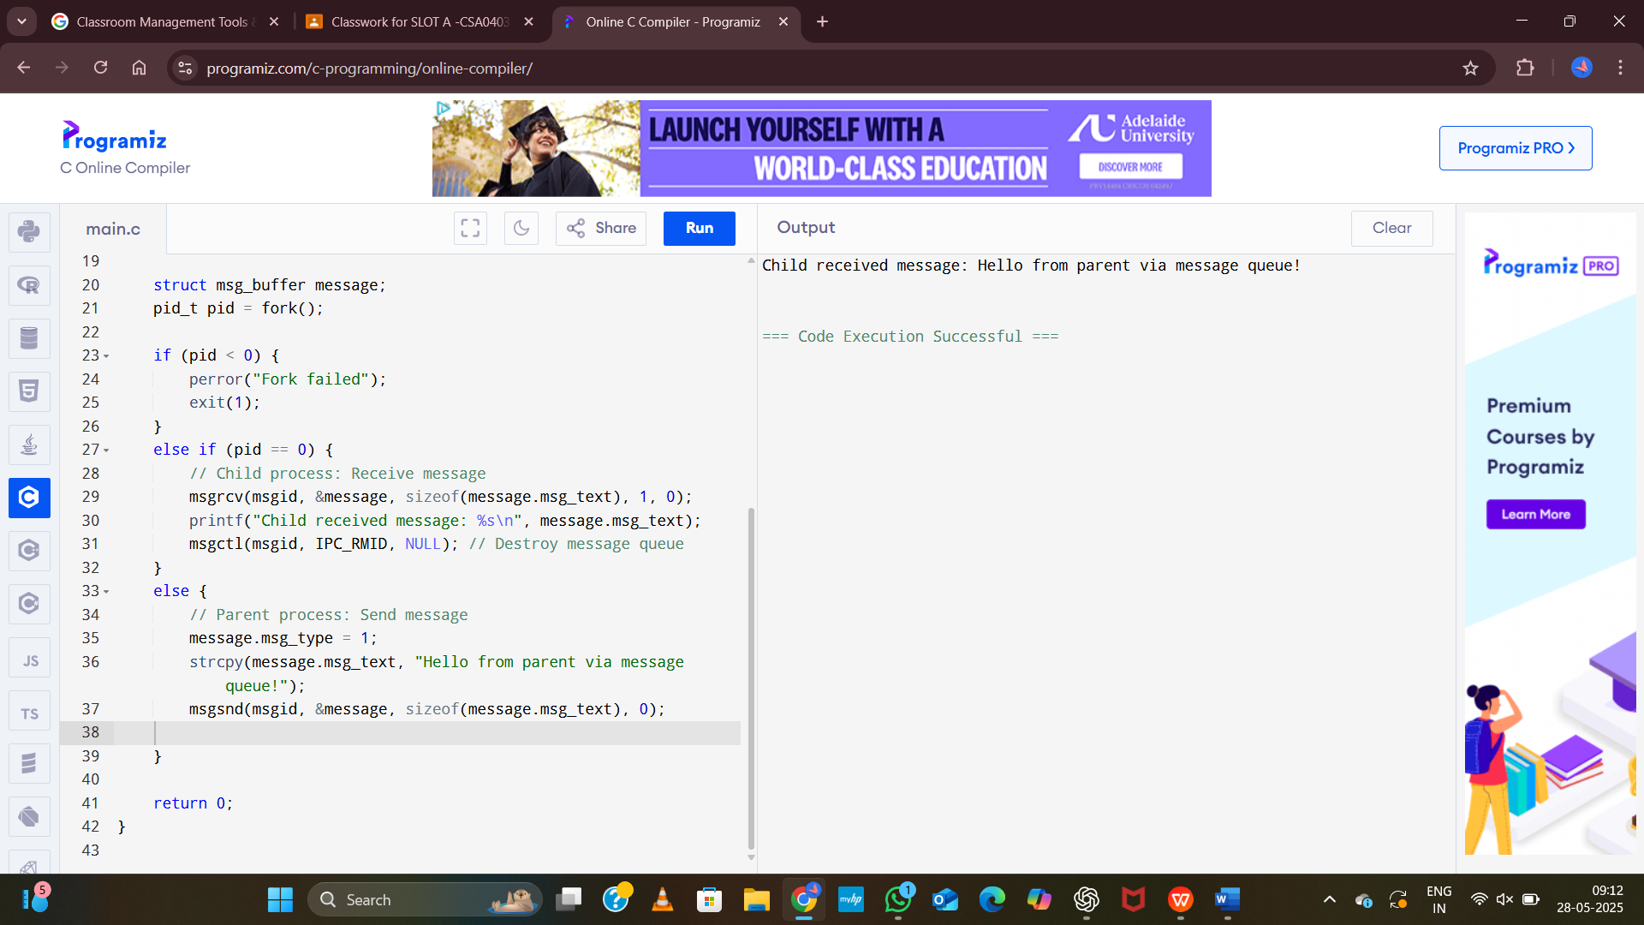

**Exp:11**

Illustrate the concept of multithreading using a C program.

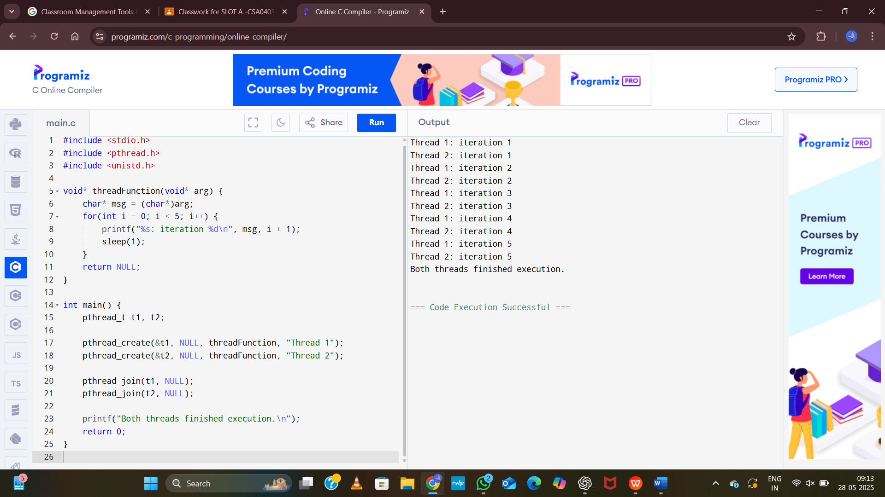

**Exp:12**

Design a C program to simulate the concept of Dining-Philosophers problem

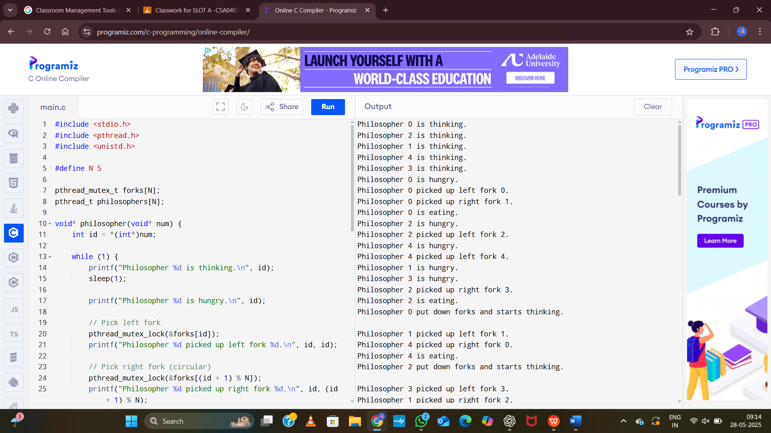

**Exp:13**

Construct a C program for implementation the various memory allocation strategies.

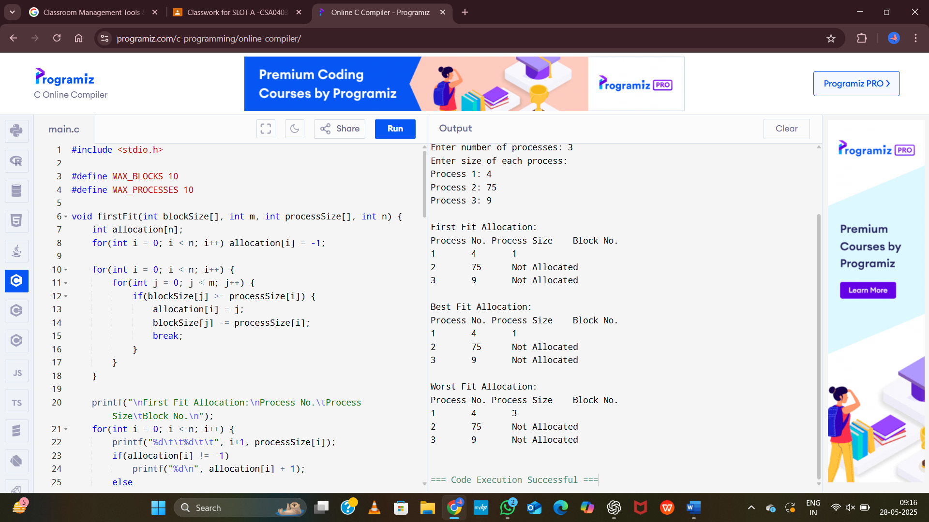

**Exp:14**

Construct a C program to organize the file using single level directory.

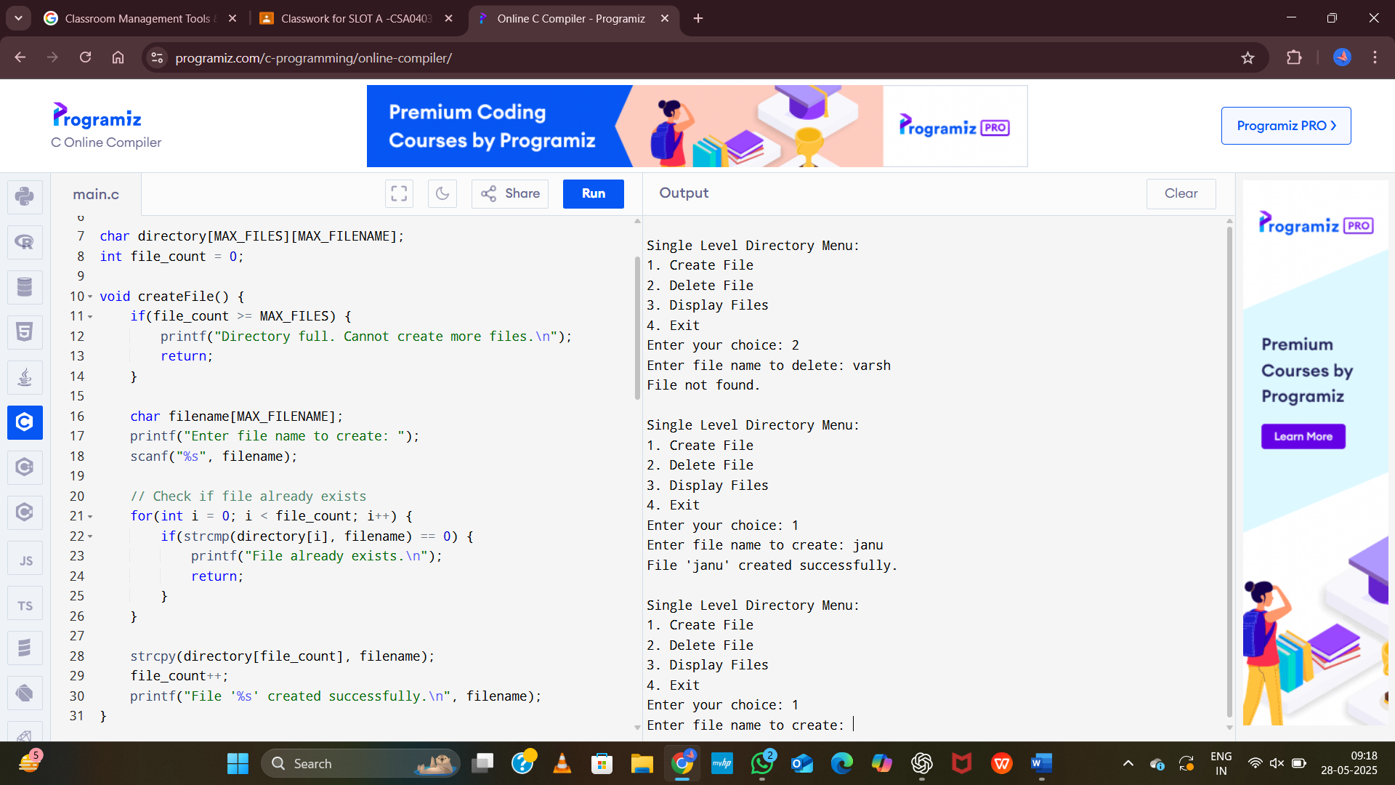

**Exp:15**

Design a C program to organize the file using two level directory structure.

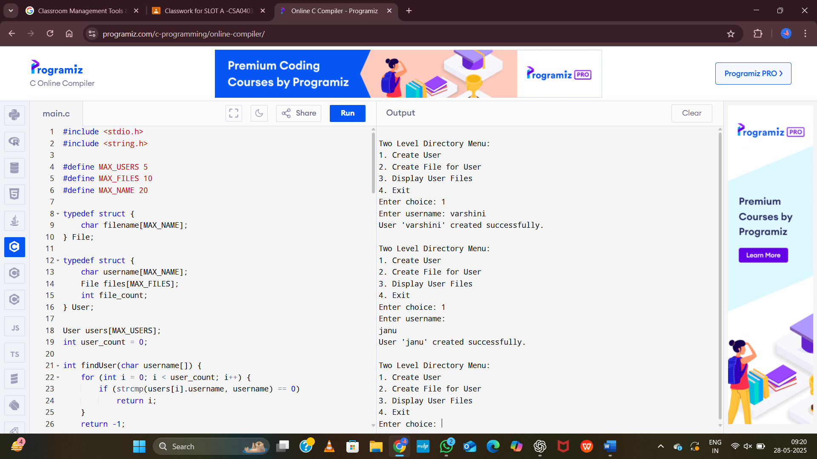

**Exp:16**

Develop a C program for implementing random access file for processing the employee

details.

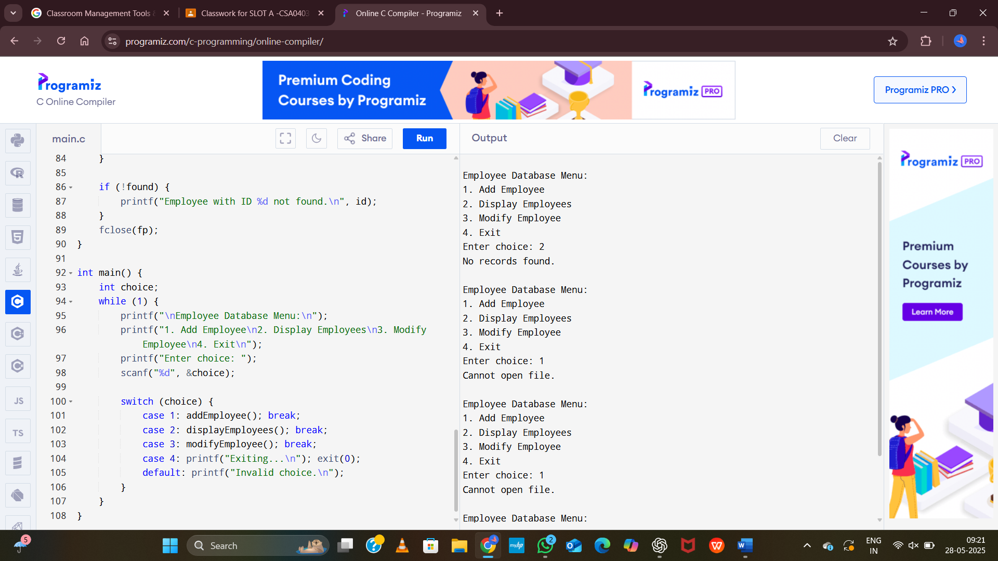

**Exp:17**

Illustrate the deadlock avoidance concept by simulating Banker’s algorithm with C.

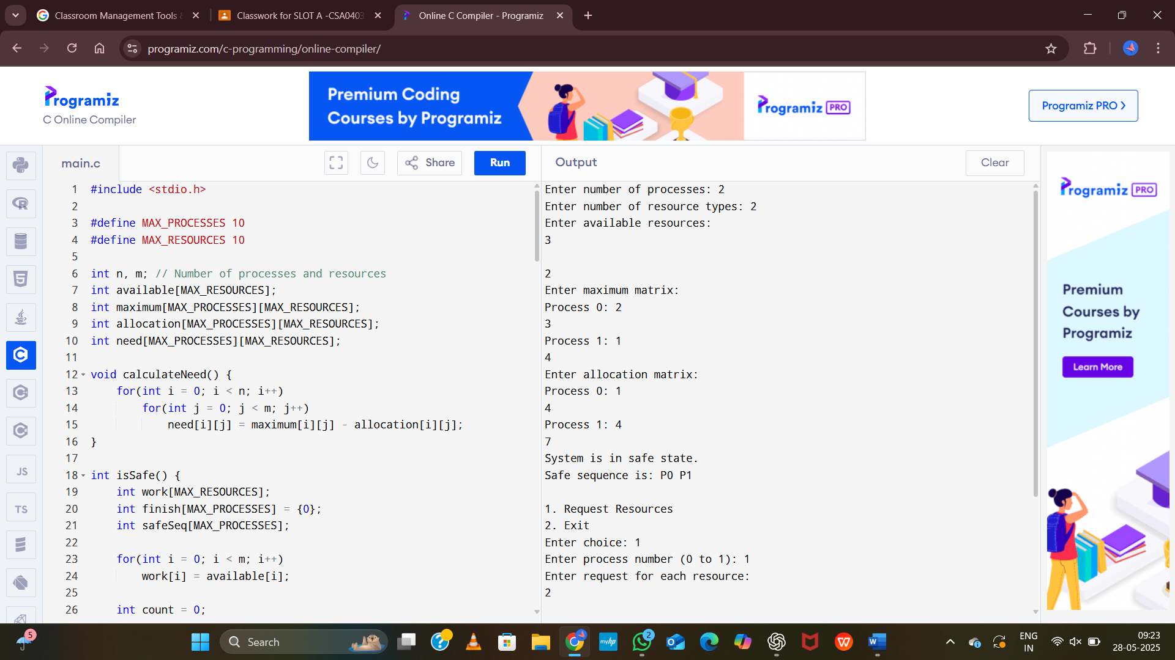

**Exp:18**

Construct a C program to simulate producer-consumer problem using semaphores.

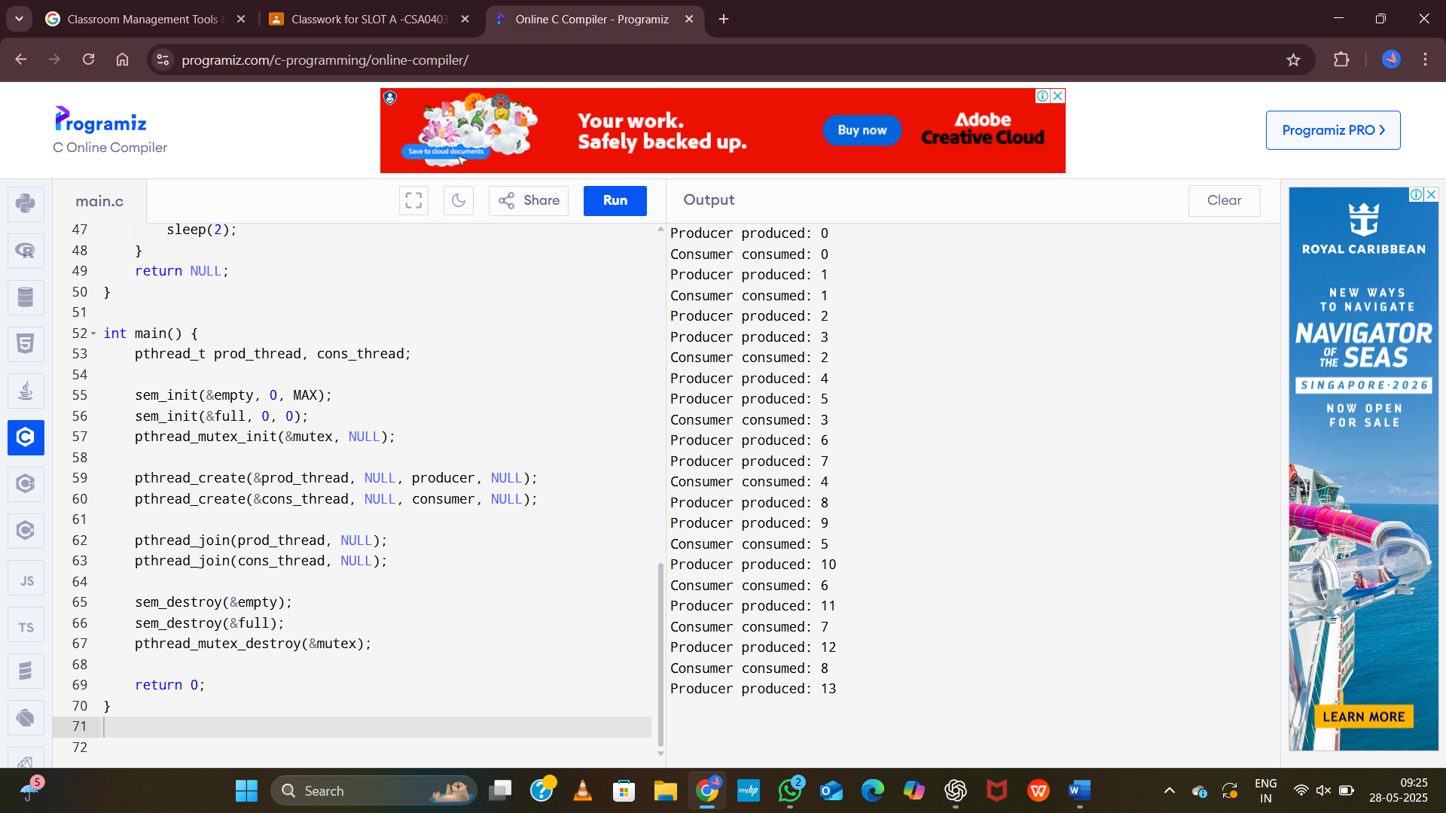

**Exp:19**

Design a C program to implement process synchronization using mutex locks.

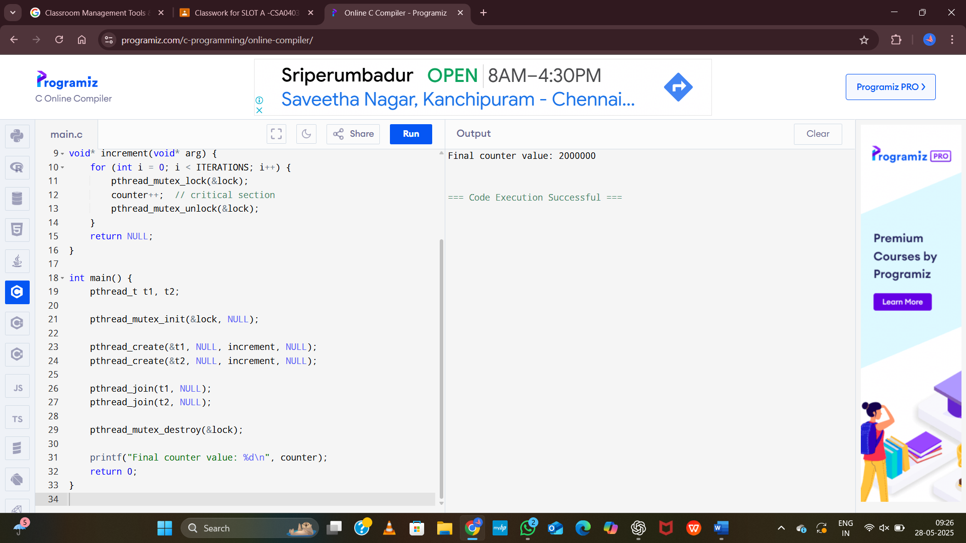

**Exp:20**

Construct a C program to simulate Reader-Writer problem using Semaphores.

